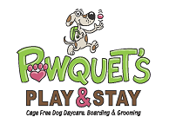

MEDICAL AUTHORIZATION

In the event that medical attention is needed, Pawquet’s Play & Stay will make reasonable effort to contact you or your emergency contact. If we cannot reach you or your emergency contact we will contact your veterinarian and will seek their advice. If we cannot contact your veterinarian we will contact and/or transport your dog to the nearest available Emergency Veterinarian Hospital or Clinic.
Please let us know your preference:
- Provide treatment to my dog not to exceed $_________________
- Provide whatever treatment is necessary and allow the veterinarian or emergency contact to make the medical and financial decisions. I agree to be responsible for all costs for treatment.
I authorize Pawquet’s Play & Stay to transport my dog to either facility as listed above.
I acknowledge that I have read and agree to the above Medical Authorization.
Owner/Parent Name and Address: ______________________________________________________
___________________________________________________________________________________
Telephone: ________________________ Email: ______________________________________

Dated: ____________________ ____________________________________________
Parent Signature

